**SUPPLEMENTARY MATERIAL**

**Approximating species age from phylogenies under different speciation modes and extinction**

Carlos Calderón del Cid1,2, Torsten Hauffe2, Juan D. Carrillo2, Rachel C. M. Warnock3, Daniele Silvestro2,4

1Laboratório de Ecologia Espacial, Instituto de Biologia, Universidade Federal da Bahia, CEP 40170-110, Salvador, Bahia, Brasil

2Department of Biology, University of Fribourg, Switzerland and Swiss Institute of Bioinformatics, Fribourg, Switzerland

3Erlangen

4Department of Biological and Environmental Sciences and Gothenburg Global Biodiversity Centre, University of Gothenburg, Sweden

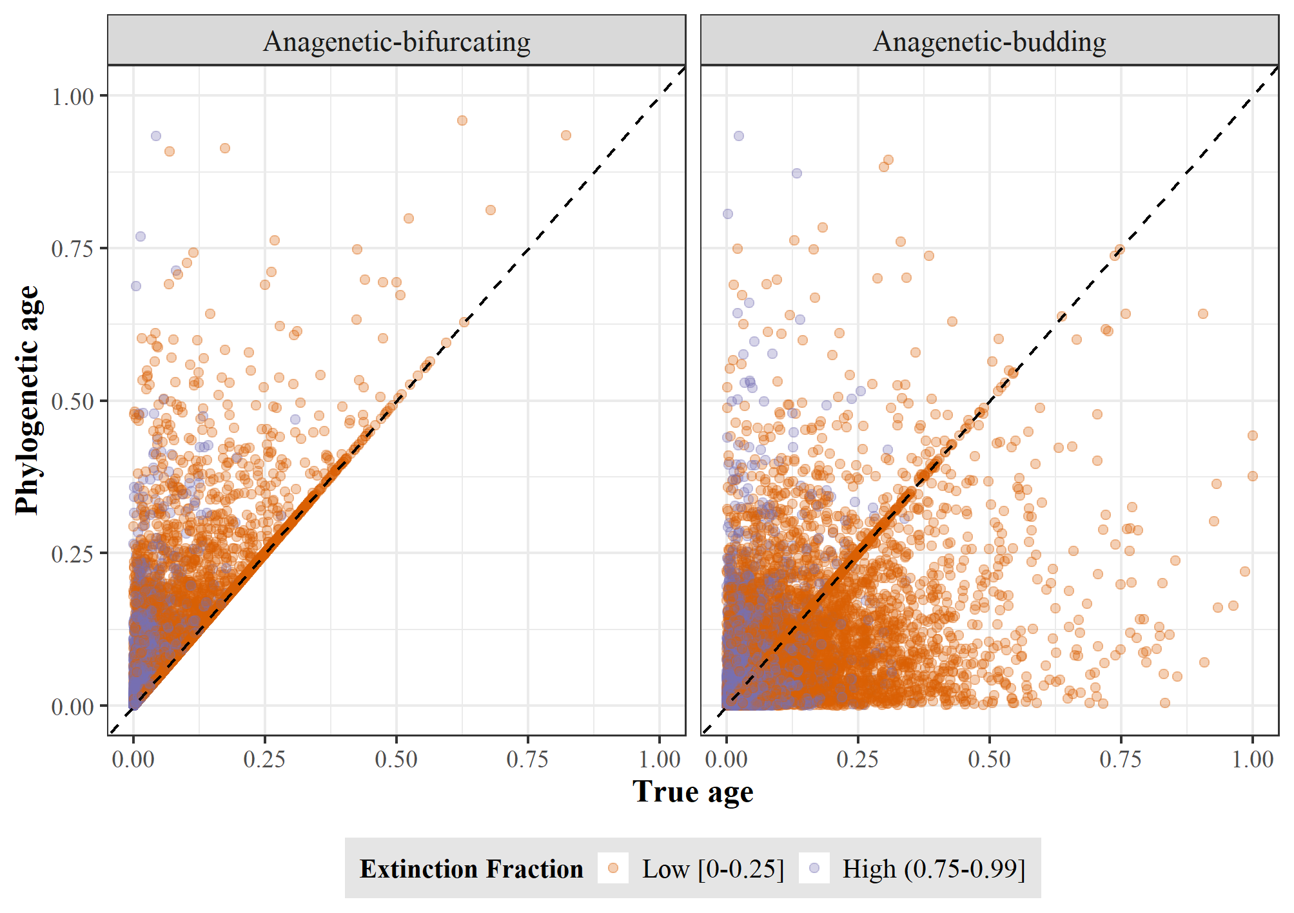

**Figure SM1.** True age versus phylogenetic age at low and high extinction fraction for Anagenetic-bifurcating (left) and Anagenetic-budding (right) speciation. Each point represents a species. True and phylogenetic ages are scaled to the root age of the correspondent phylogenetic tree.

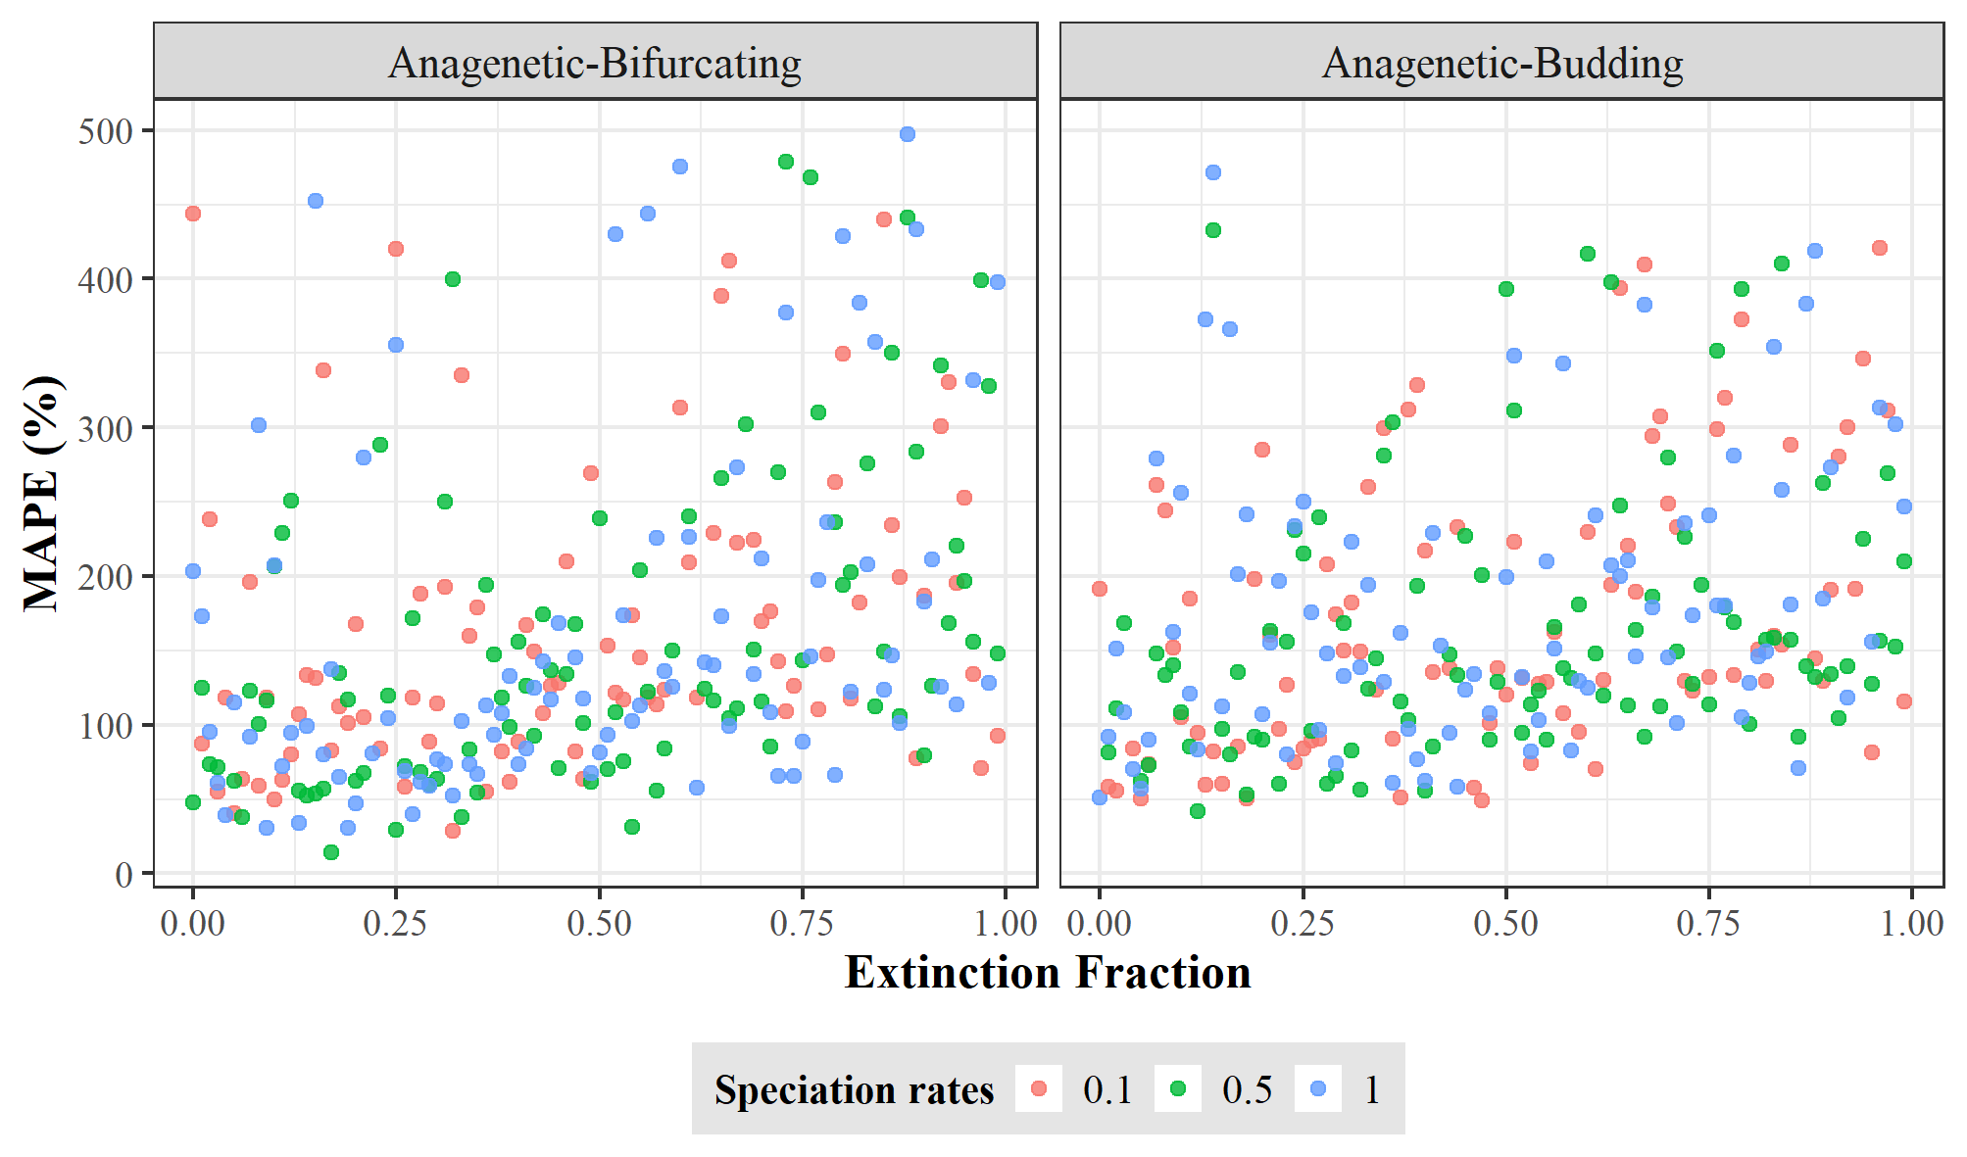

**Figure SM2.** Error in equating phylogenetic age with speciation age. The error was quantified as mean absolute percentage error (MAPE) between the true and phylogenetic ages across all species for each tree simulated under Anagenetic-bifurcating (left) and Anagenetic-budding speciation (right). Each dot represents one replicate of the 300 trees for each speciation mode using different rates of speciation and extinction fraction.

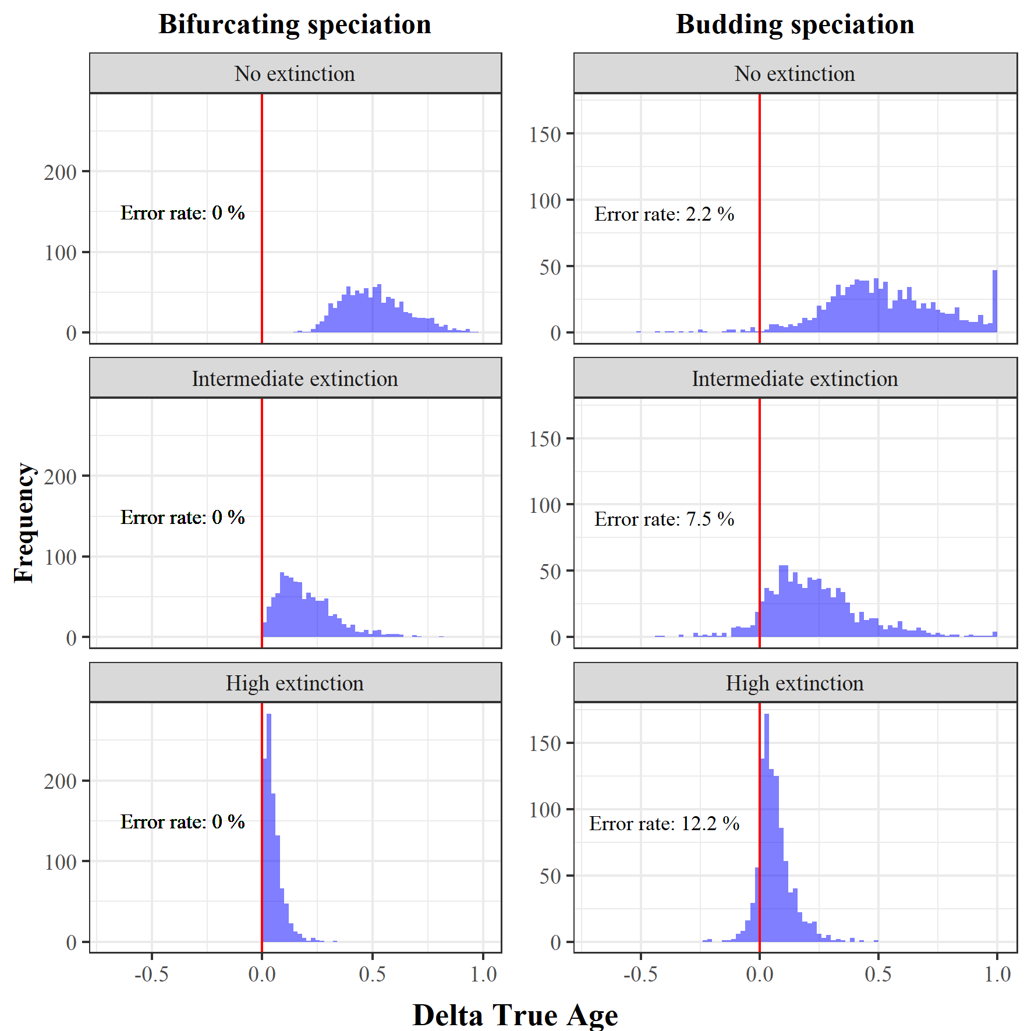

**Figure SM3.** Error in estimating the relative age of species. For each of the 1000 simulations under bifurcating (left) and budding (right) speciation, combined with three different extinction levels, we selected the oldest and youngest species according to the phylogenetic ages, and calculated the difference in their true ages (ΔTrue age). A ΔTrue age smaller than 0 indicates that the phylogenetic oldest species was estimated to be in fact younger than the phylogenetic youngest species, and therefore, the comparison of phylogenetic ages is qualitatively wrong.

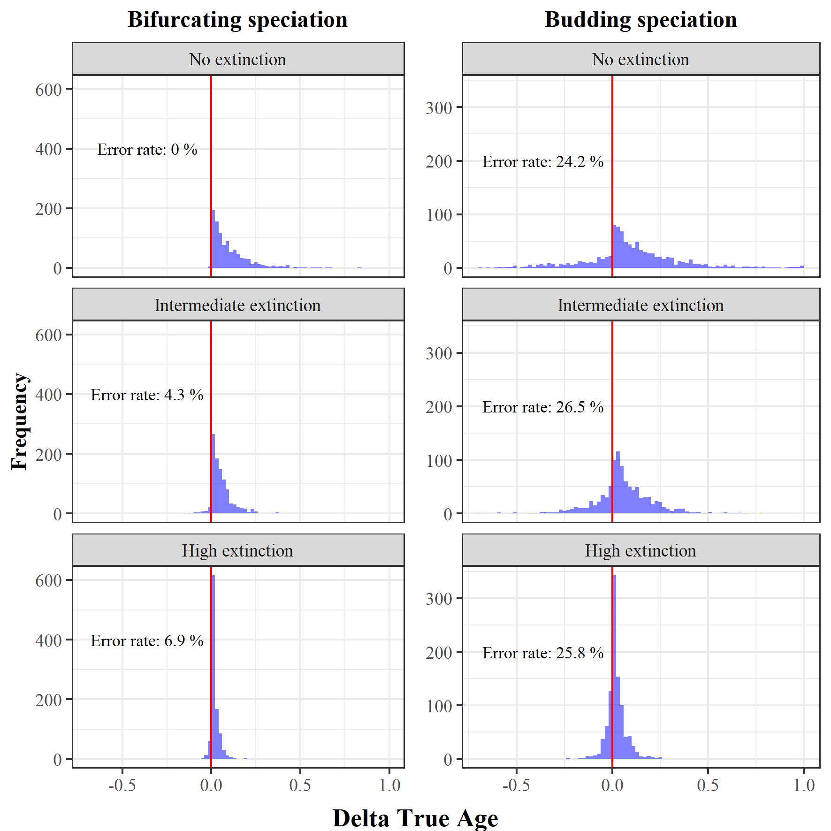

**Figure SM4.** Risk to confuse older with younger random species. For each of the 1000 simulations under bifurcating (left) and budding (right) speciation, combined with three different extinction levels, we selected two random species and defined which was the older and younger according to the phylogenetic ages, and calculated the difference in their true ages (ΔTrue age). A ΔTrue age smaller than 0 indicates that the phylogenetic older species was in fact younger than the phylogenetic younger species, and therefore, the comparison of phylogenetic ages is qualitatively wrong.

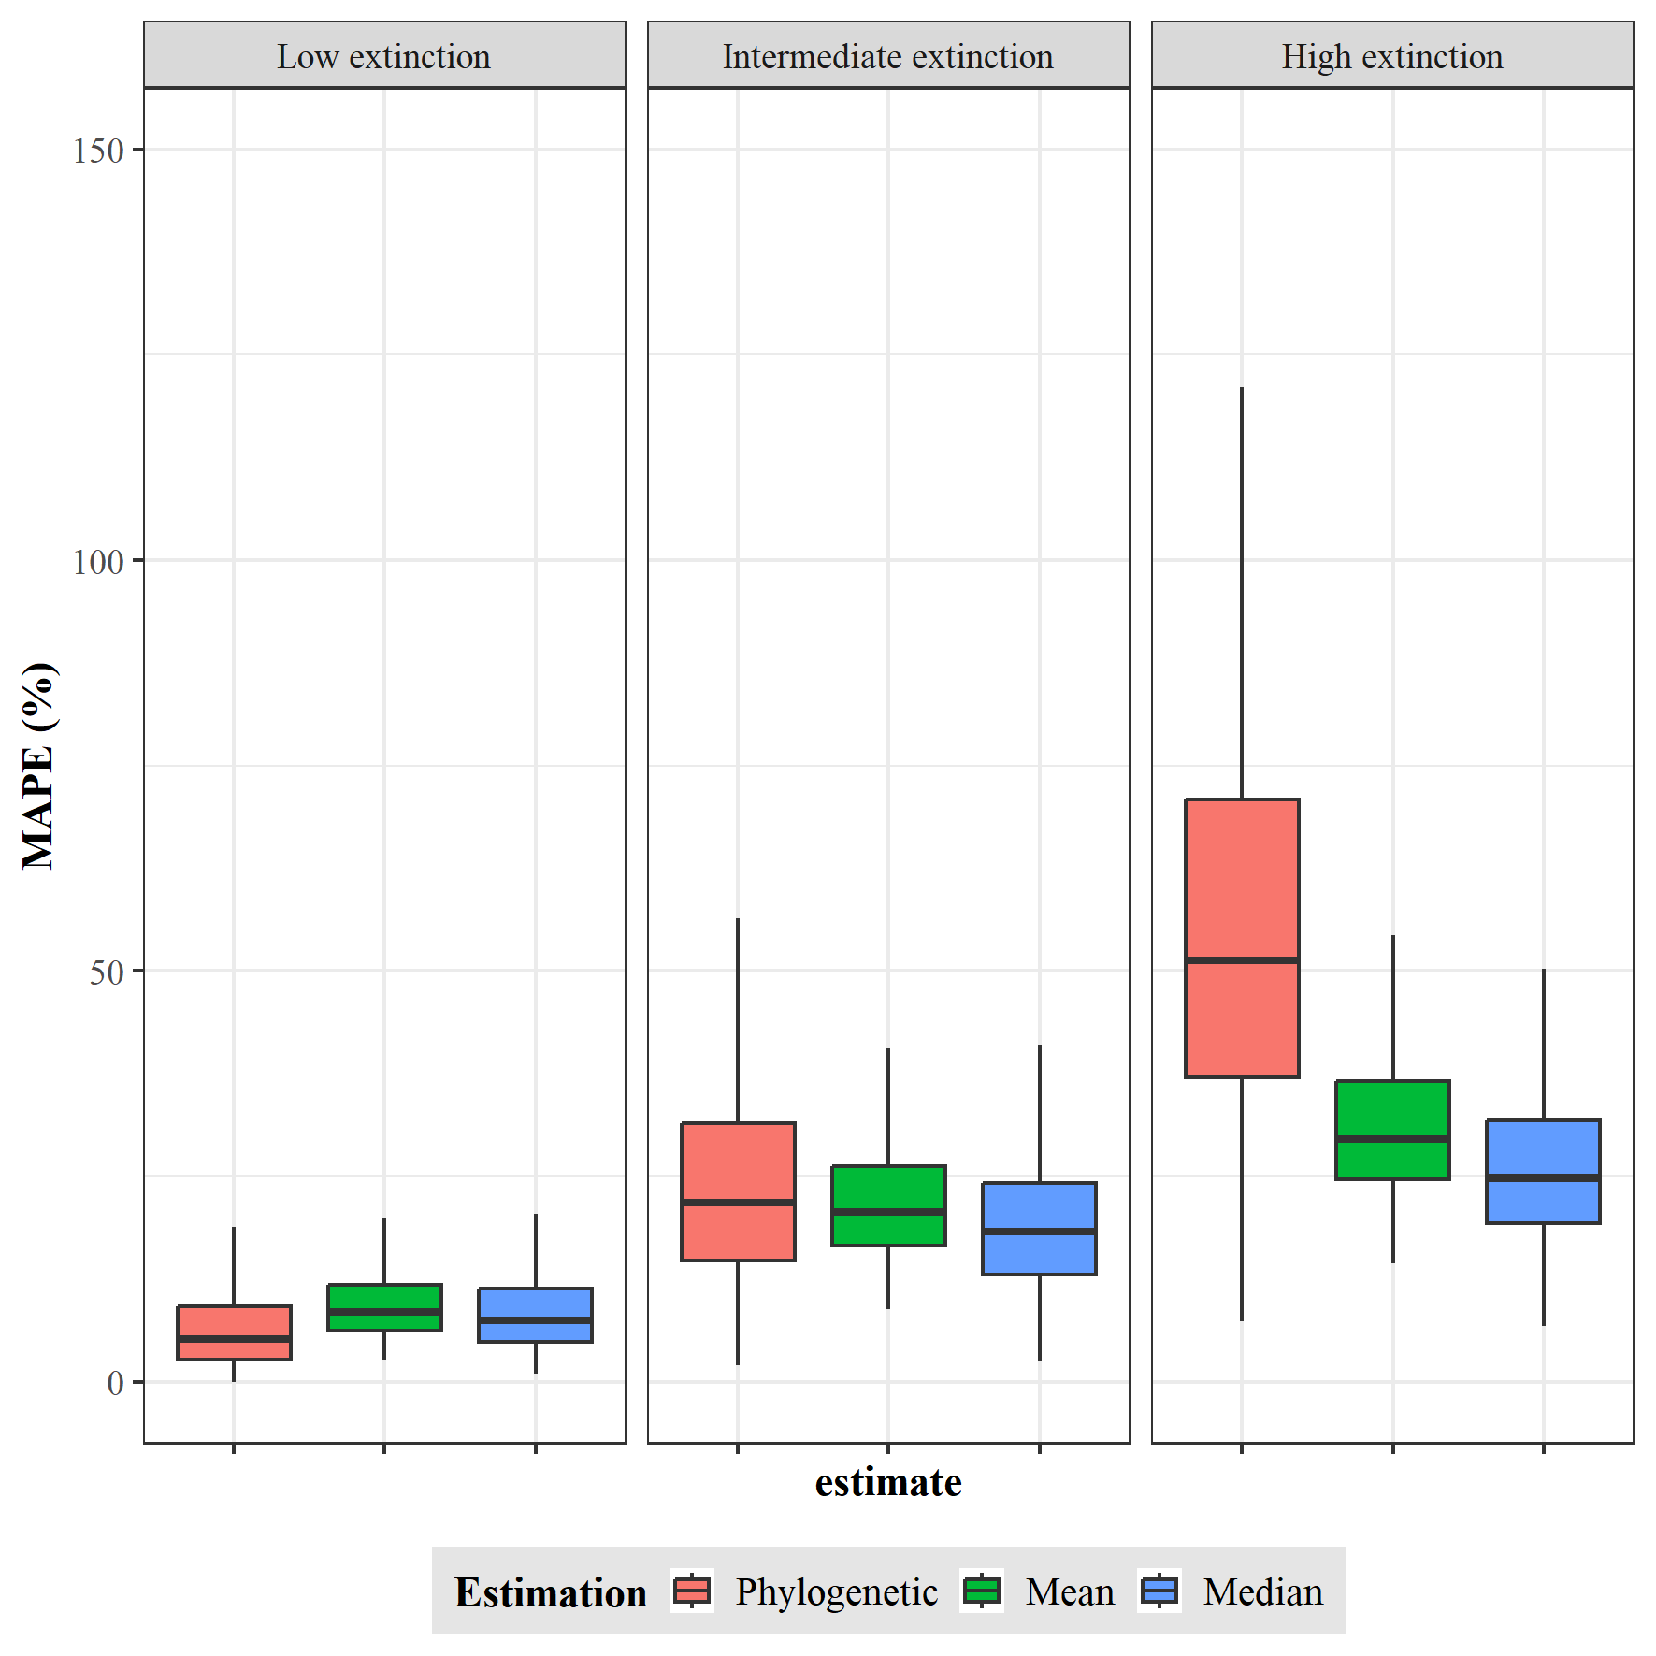

**Figure SM5**. Performance of a probabilistic age estimator. Error in equating the phylogenetic age and the probability estimator point estimates (mean and median) with the true species age for three extinction scenarios (low, intermediate, and high; from left to right). The error was quantified as mean absolute percentage error (MAPE) between the true and point estimates or phylogenetic ages across 100 species for each of 1000 trees for each extinction scenario simulated under bifurcating speciation.

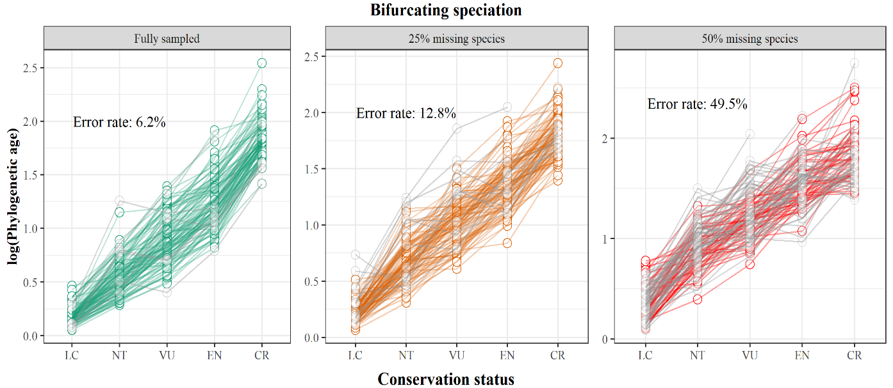

**Figure SM6.** Impact of incomplete taxon sampling on detecting an age extinction-risk relationship. Simulated species ages under an intermediate extinction scenario and assuming bifurcating speciation were binned into conservation status categories, which represents an increase in extinction risk by true age (LC = Least Concern; NT = Near Threatened; VU = Vulnerable; EN = Endangered; CR = Critically Endangered). We used the phylogenetic age from fully sampled phylogenies (green), and two incomplete taxon sampling levels 25% (orange) and 50% (red) of missing extant species, to calculate the mean age per conservation status category and assess if every mean age increases over the one of the previous category with lower extinction risk. The error rate is the percentage across all 1000 phylogenies where the relationship between the mean ages and the conservation status categories is not always increasing (shown by grey lines).